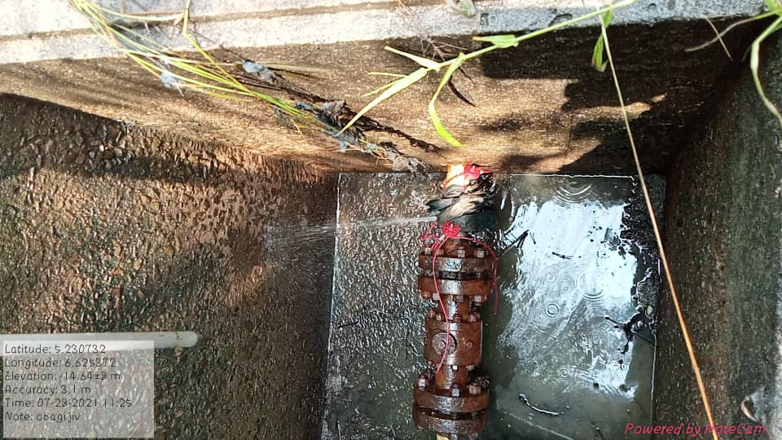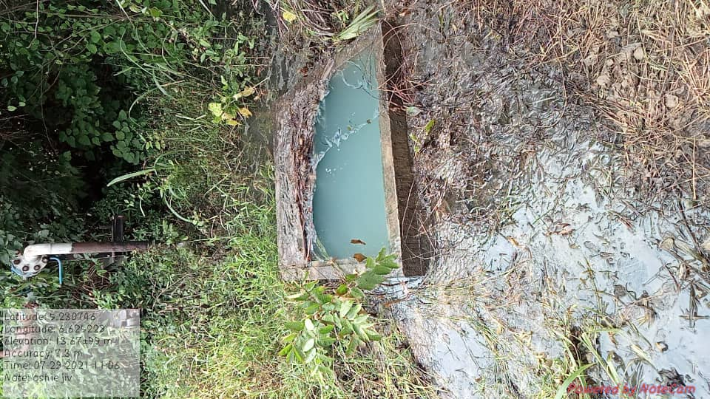
Fig 1. Arrow showing spill point with hack saw cut Fig.2. Area impacted within ROW

